 | COEP Technological University, Pune  A Unitary Public University of Government of Maharashtra  Department of Applied Sciences & Humanities  (School of Transdisciplinary Sciences & Management)  Wellesley Road, Chhatrapati Shivajinagar, Pune - 411005. | 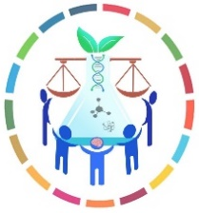
Biology for Engineers - Classnotes

-------------------------------------------------------------------------------------------------------------------------------

UNIT V: APPLICATION AREAS OF BIOENGINEERING

Databases & Biocomputing: Acquisition, storage, processing and transmission of biological data and its applications like PCR
Bioinstrumentation: Diagnostic and Therapeutic devices
Bioimaging: Principle, types and examples,
Biosensors: Principle, types and examples,
Application of Artificial Intelligence in bio-medical field

-------------------------------------------------------------------------------------------------------------------------------

Distributed Information Processing in Biological and Computational Systems
Biological systems, ranging from the molecular to the cellular to the organism level, are distributed and in most cases operate without central control. Such systems must solve information processing problems that are often very similar to problems faced by computational systems, including coordinated decision making, leader election, routing and navigation, and more. Over the last few years our ability to study and model biological systems has improved dramatically. Using advanced sequencing technologies we can now determine the composition of the genomes of hundreds of organisms. For specific cells and tissues we can query the set of active genes, their expression levels, and how their responses change in different conditions and over time. We can also determine which molecules within cells interact and how such interactions are wired to form the control diagram regulating cellular activity. Using this data we can build models of information processing within and between cells and answer questions regarding the methods biological systems use to achieve their goals that were out of reach even a few years ago. This data can also help us understand what computational problems are being solved by biological systems and how, which in turn can lead to specific algorithms that may also benefit computational systems.
Video: Distributed Information Processing in Biological and Computational Systems on Vimeo

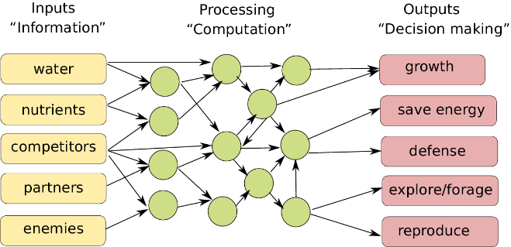 | Biological computing All biological organisms, be it primates, snails, plants or single-celled amoebas, sense their environment and internal state, and process, integrate and prioritise this information to compute which action to take next. Figure inspired on earlier work in Scheres and van der Putten  (Reference Scheres and van der Putten2017).

Defense system in Yeast: The robust defenses that yeast cells have evolved to protect themselves from environmental threats hold lessons that can be used to design computer networks and analyze how secure they are (Computer scientists at Carnegie Mellon University). Environmental “noise” is a key evolutionary pressure that shapes the interconnections within cells, as well as those of neural networks and bacterial/ecological networks. The researchers factored this into an established model for the evolution of molecular connections, resulting in an algorithm that gives rise to a rich range of architectures found in biological, computer and other types of networks.

It is said that this approach is particularly helpful in understanding how networks respond to cascading failures, whether it be an overloaded power grid or a computer network being overwhelmed by fake identities in a so-called sybil attack.

The generative model the CMU team developed can be used to tailor networks to the environments in which they are expected to operate. These strike a balance between highly connected networks that are efficient and fast but are prone to infections and cascading failures, such as the Internet and its large service providers, and more sparsely connected elements that are less efficient, requiring more time to relay information, but can better tolerate failures and attacks, such as peer to peer networks.

That’s a balance that evolution already has achieved in yeast. A yeast cell has about 6,000 genes, of which 20 percent are considered essential — that is, if the gene is removed, the cell dies. But Ziv Bar-Joseph, an associate professor in the Machine Learning Department and the Lane Center for Computational Biology, said that view of what is essential and what isn’t reflects how scientists study genes — by noting their effects on an organism when a gene is removed — not necessarily the gene’s importance.
“The cell did not evolve to protect itself against the deletion of these ‘essential’ genes,” Bar-Joseph said, noting that’s an event that doesn’t often occur in nature.
Rather, the fragility of genes, proteins and other cell components may reflect exposure to their environment. Those that lie near the cell surface, for instance, can expect to encounter lots of environmental stress, so the cell has evolved to tolerate the loss of some of them. Those involved in DNA duplication, on the other hand, normally don’t experience that kind of exposure to noise and so don’t have the same robust interconnections. That’s why the cell dies if one of those genes is removed, Bar-Joseph noted.
Just as biologists study genes by knocking them out, one by one, computer scientists often evaluate network security by removing a server and seeing how the network responds. But Navlakha said that’s not always realistic; many attacks or failures of computer and electrical networks can involve the loss of multiple, neighboring nodes.
To better understand the significance of how various networks are interconnected, the Carnegie Mellon researchers, including Christos Faloutsos, professor of computer science, and Xin He, a Lane Fellow in computational biology, modified the well-known duplication-divergence model used to explain the evolution of molecular networks. The concept is that gene duplication can result in two equivalent proteins that, over time, diverge to develop specialized subtasks, while also maintaining common connections.
By adjusting the duplication-divergence model to account for the pressure of environmental noise, the researchers developed a method that can be used to generate or evaluate the interconnection, or topology, of networks that work in a variety of environments. A military network, for instance, might not worry about malevolent viruses and noise because access is restricted, while a wireless sensor network deployed over a wide area might need to tolerate continual losses of random nodes.
At the same time, the evolutionary role of external noise might well prove to be an insight that will enhance the understanding of biological networks, Bar-Joseph added.

A comparative approach for the investigation of biological information processing: an examination of the structure and function of computer hard drives and DNA
Background: The robust storage, updating and utilization of information are necessary for the maintenance and perpetuation of dynamic systems. These systems can exist as constructs of metal-oxide semiconductors and silicon, as in a digital computer, or in the "wetware" of organic compounds, proteins and nucleic acids that make up biological organisms. We propose that there are essential functional properties of centralized information-processing systems; for digital computers these properties reside in the computer's hard drive, and for eukaryotic cells they are manifest in the DNA and associated structures.

Different spatial organisations of information processing in biological systems.  Left: centralised information processing based on a central dominant brain in primates  Middle: hybrid information processing in an octopus that combines a central brain with semi-autonomous information processing in its arms.  Right: fully distributed information processing with no central processing organ in plants | 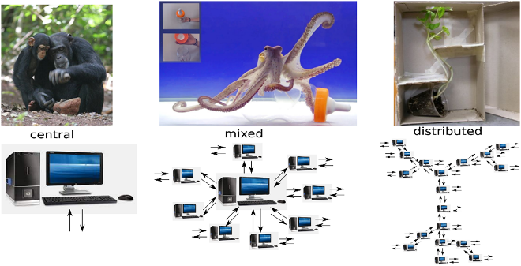

A descriptive framework is presented herein that compares DNA and its associated proteins and sub-nuclear structure with the structure and function of the computer hard drive. We can identify four essential properties of information for a centralized storage and processing system: (1) orthogonal uniqueness, (2) low level formatting, (3) high level formatting and (4) translation of stored to usable form. The corresponding aspects of the DNA complex and a computer hard drive are categorized using this classification. This is intended to demonstrate a functional equivalence between the components of the two systems, and thus the systems themselves.

Both the DNA complex and the computer hard drive contain components that fulfill the essential properties of a centralized information storage and processing system. The functional equivalence of these components provides insight into both the design process of engineered systems and the evolved solutions addressing similar system requirements. However, there are points where the comparison breaks down, particularly when there are externally imposed information-organizing structures on the computer hard drive.

A specific example of this is the imposition of the File Allocation Table (FAT) during high level formatting of the computer hard drive and the subsequent loading of an operating system (OS). Biological systems do not have an external source for a map of their stored information or for an operational instruction set; rather, they must contain an organizational template conserved within their intra-nuclear architecture that "manipulates" the laws of chemistry and physics into a highly robust instruction set. We propose that the epigenetic structure of the intra-nuclear environment and the non-coding RNA may play the roles of a Biological File Allocation Table (BFAT) and biological operating system (Bio-OS) in eukaryotic cells.

The comparison of functional and structural characteristics of the DNA complex and the computer hard drive leads to a new descriptive paradigm that identifies the DNA as a dynamic storage system of biological information. This system is embodied in an autonomous operating system that inductively follows organizational structures, data hierarchy and executable operations that are well understood in the computer science industry. Characterizing the "DNA hard drive" in this fashion can lead to insights arising from discrepancies in the descriptive framework, particularly with respect to positing the role of epigenetic processes in an information-processing context. Further expansions arising from this comparison include the view of cells as parallel computing machines and a new approach towards characterizing cellular control systems.

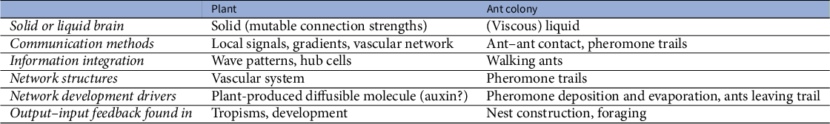

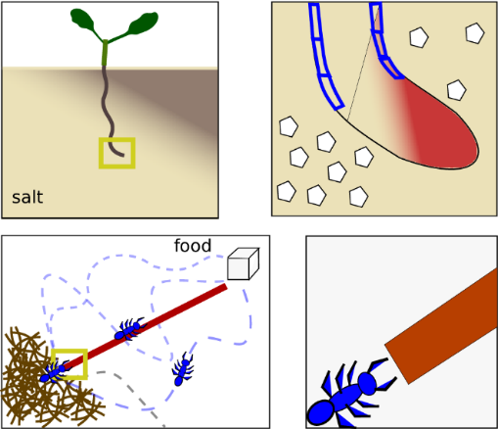 | Storage of spatial environmental information. Top: in the solid brain setting of a plant root, environmental information regarding the direction of a salt gradient can be stored internally in the shape of an auxin asymmetry. Bottom: in the liquid brain setting of an ant colony, environmental information regarding the direction and shortest path towards a food source is stored externally through a pheromone trail.

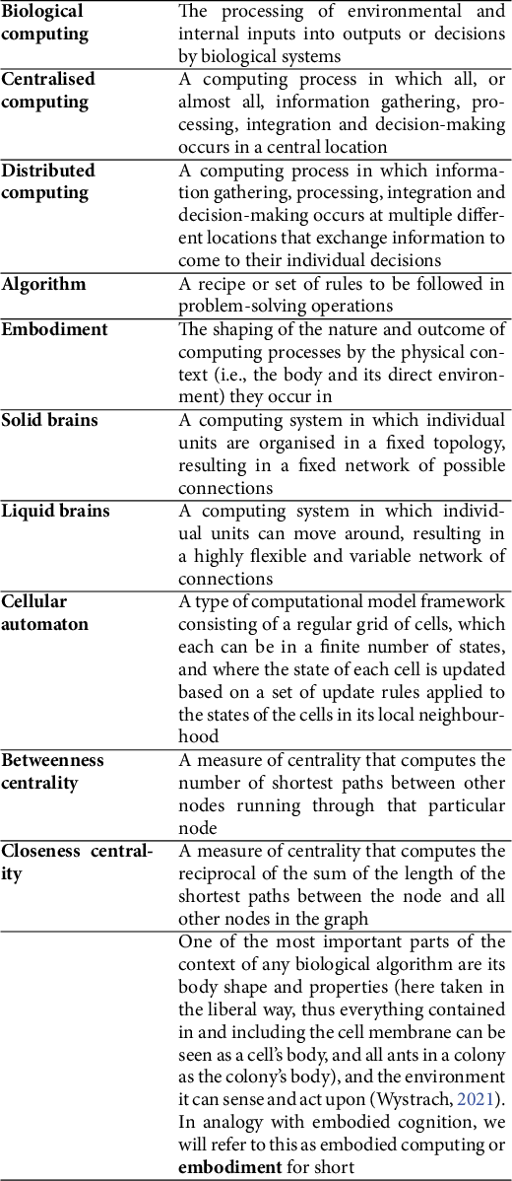
Source: A review article by Saket Navlakha, Ziv Bar-Joseph Communications of the ACM, January 2015, Vol. 58 No. 1, Pages 94-102
DNA Replication
DNA is capable of self reproduction. Parent DNA produces two daughter DNA molecules which are exact copies / replicas of parent DNA in N2 base sequence. Hence DNA duplication is called as DNA replication.
Definition-- It is making exact copies of parent DNA. It is bidirectional.

Steps of DNA Replication --

1)The first major step for the DNA Replication to take place is the breaking of hydrogen bonds between bases of the two antiparallel strands. The unwounding of the two strands is the starting point.

2)Activation of deoxyribonucleotides by energy & enzyme Phosphorylase.

3)Enzyme Endonuclease makes cut to one of the strands of DNA. The splitting happens in places of the chains which are rich in A-T. That is because there are only two bonds between Adenine and Thymine (there are three hydrogen bonds between Cytosine and Guanine). Helicase is the enzyme that splits the two strands. The initiation point where the splitting starts is called "origin of replication". The structure that is created is known as "Replication Fork”.

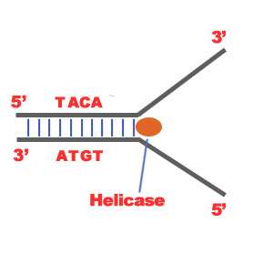
4)Topoisomerase, helix destabilizing protein stabilize replication fork.
5) Primase synthesizes RNA primer that attaches at 3’ end. RNA primer functions as 5’ end of new strand.
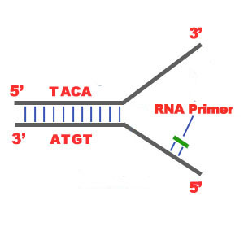
6) Two separated strands function as templates. Initiation of replication occurs at 3’ end.
7) DNA polymerase adds nucleotides in 5’ → 3’direction continuously complementary to the nucleotides of the template, e.g. A—T. This strand is called leading strand.
8) On the other strand DNA polymerase adds nucleotides in 5’ → 3’direction in short fragments. Hence it is called as lagging strand. The newly synthesized DNA fragments are called as Okazaki fragments. These fragments are joined by DNA ligase & become continuous.
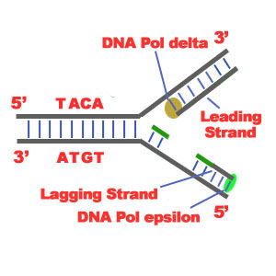

9) Once replication is completed, RNA primer is removed& DNA nucleotides are synthesized by DNA polymerase.

10) Proof reading – Mismatched N2 bases are removed by endonuclease & appropriate N2 bases are introduced by DNA polymerase.
11) In daughter DNA, 2 strands coil around each other to form helix.
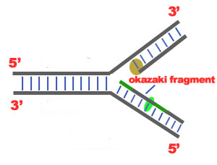
12) Thus in daughter DNA one strand is old i.e. conserved & another strand is new. Hence it is known as “semiconservative replication”.
Protein Synthesis:
Protein synthesis is the main mechanism in body with respect to growth and changes in the cell. It results in the production of amino acid chains which are for proteins (important component in body). But for short term reactions importance of protein synthesis is the production of variety enzymes for different reactions as needed by the body for that moment. Since we cannot exist without enzymes, protein synthesis is needed for our existence. The process of protein synthesis translates the codons (nucleotide triplets) of the messenger RNA (mRNA) into the 20-symbol code of amino acids that build the polypeptide chain of the proteins.
DNA mRNA PROTEIN is known as CENTRAL DOGMA in the process of protein synthesis. It has 2 steps – transcription (DN mRNA) and translation (mRNA PROTEIN).
TRANSCRIPTION
The first step in protein synthesis is the transcription of mRNA from a DNA gene in the nucleus. In this phase, one strand of DNA double helix acts as a template to synthesize its complimentary strand i.e. mRNA. Transcription starts with an enzyme called polymerase copying the DNA sequence to a similar molecule called messenger RNA (mRNA). This synthesis takes place in a specific portion of DNA which is known as transcription bubble. In the bubble, DNA strands are separated or unzipped
The process of mRNA translation begins from its 5′-end towards its 3′-end as the polypeptide chain is synthesized from its amino-terminal (N-end) to its carboxyl-terminal (C-end). It replaces T with U (Uracil), a helper base, making it clear that the mRNA is a copy. The bases (A, T, G, C) on one strand of the DNA specify the order of bases on the new strand of mRNA (A, U, G, C). At the end of transcription, DNA stays inside the nucleus while the RNAs migrate from the nucleus into the cytoplasm.
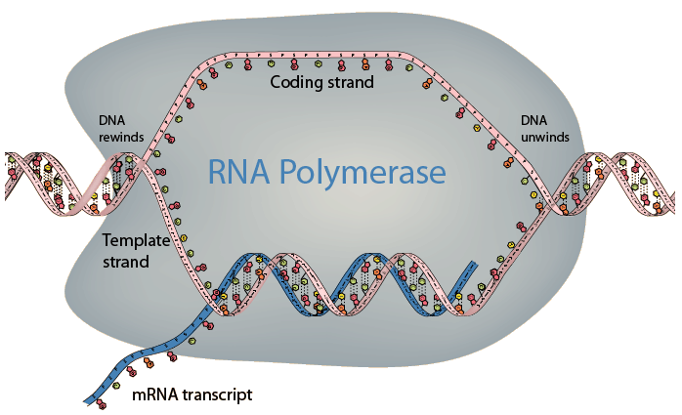
TRANSLATION
This is the second phase of protein synthesis where the ribosomes in the cytoplasm use transfer RNA (tRNA) to attach to the mRNA and translate the bases into amino acids. tRNA molecules bring the specified amino acids that the ribosome links together to make a protein. Translation has four steps viz. Activation and charging, Initiation, Elongation and Termination
Before the actual translation, activation, which is not part of translation in technical sense, occurs. In this step, the correct amino acid (AA) is joined to the correct t RNA. It is required for translation to proceed. When the activated tRNA has an amino acid linked to it, it is termed as "charged". The AA is joined by its carboxyl group to the 3' OH of the tRNA by an ester bond.

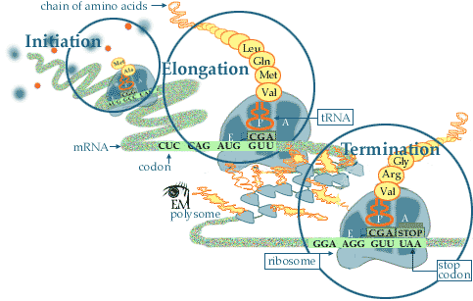

Initiation: In the cytoplasm, protein synthesis is actually initiated by the AUG codon on mRNA. The AUG codon signals both the interaction of the ribosome with m-RNA and also the tRNA with the anticodons (UAC). The tRNA which initiates the protein synthesis has N-formyl-methionine attached. The formyl group is really formic acid converted to an amide using the -NH₂ group on methionine (left most graphic)
The next step is for a second tRNA to approach the mRNA (codon - CCG). This is the code for proline. The anticodon of the proline tRNA which reads this is GGC. The final process is to start growing peptide chain by having amine of proline to bond to the carboxyl acid group of methinone (met) in order to elongate the peptide.
Elongation: Elongation of the peptide begins as various tRNA's read the next codon. In the example on the left the next tRNA to read the mRNA is tyrosine. When the correct match with the anticodons of a tRNA has been found, the tyrosine forms a peptide bond with the growing peptide chain. The proline is now hydrolyzed from the tRNA. The proline tRNA now moves away from the ribosome and back into the cytoplasm to reattach another proline amino acid.
Elongation and Termination: When the stop signal on mRNA is reached, the protein synthesis is terminated. The last amino acid is hydrolyzed from its t-RNA. The peptide chain leaves the ribosome. The N-formyl-methionine that was used to initiate the protein synthesis is also hydrolyzed from the completed peptide at this time.
The ribosome is now ready to repeat the synthesis several more times. The events following translation include post-translational modification and protein folding. During and after synthesis, polypeptide chains often fold to attain secondary, tertiary and quaternary structures. This process is known as maturation of protein and it takes place in Golgi Complex.

Polymerase Chain Reaction (PCR)
- It is an extremely powerful technique that allows a million fold amplification of selected DNA sequence.
- It is used to clone the given DNA sequence in vitro without using living cells during cloning process.
- It makes the use of the ability of the enzyme DNA polymerase to carry out the semi-conservative replication of DNA.
- PCR results in the amplification of a chosen region of DNA molecule when the sequences of the borders are known.
- Two synthetic oligonucleotides that are complementary to end parts of the chosen sequence can anneal to the ends of the DNA segment.
- The amplification of this segment between the two defined ends can be then continued by synthesizing or replicating the DNA with the help of a special enzyme DNA polymerase.
- The oligonucleotides act as the primers for the enzyme to complete the synthesis/replication.
- This amplification is achieved by a repetitive series of cycles involving three steps.
- Denaturation: The DNA sample to be amplified (template DNA) is denatured by heating at 92⁰C.
- Annealing: The oligonucleotide primers added to the separated template DNA strands and the temperature is reduced to 40-60 ⁰C.
- Synthesis by extending the primers: At 72⁰C DNA polymerase that has been added in the reaction mixture extends the 3’ ends of the oligonucleotide primers complementarily using the template DNA. The DNA polymerase used in PCR is a thermostable, isolated from the bacterium Thermus aquaticus. It is called Taq polymerase which survives at the high temperature required during denaturation step.
These three steps represent a single PCR cycle. The products of the first cycle are replicated for further amplification. This reaction can be performed many times to supply unlimited copies of the amplified DNA. During repetition of the cycle regular denaturation of the freshly synthesized double stranded DNA molecules is carried out.
Applications of PCR
- After 25 cycles the target DNA is amplified about 10⁶ fold.
- PCR can detect and amplify as little as 1 DNA molecule. It allows successful cloning of DNA even from samples which are more than 40,000 years old or mummified human bodies, extinct animals like wooly mammoth or dinosaurs.
- Highly useful in new fields like molecular archaeology, molecular palaeontology
- To trace the evolution of pathogenic viruses, forensic medicine, detection of viral infections before causing the disease or showing the symptoms, prenatal diagnosis of genetic disorders
- It was used for Human Genome Project

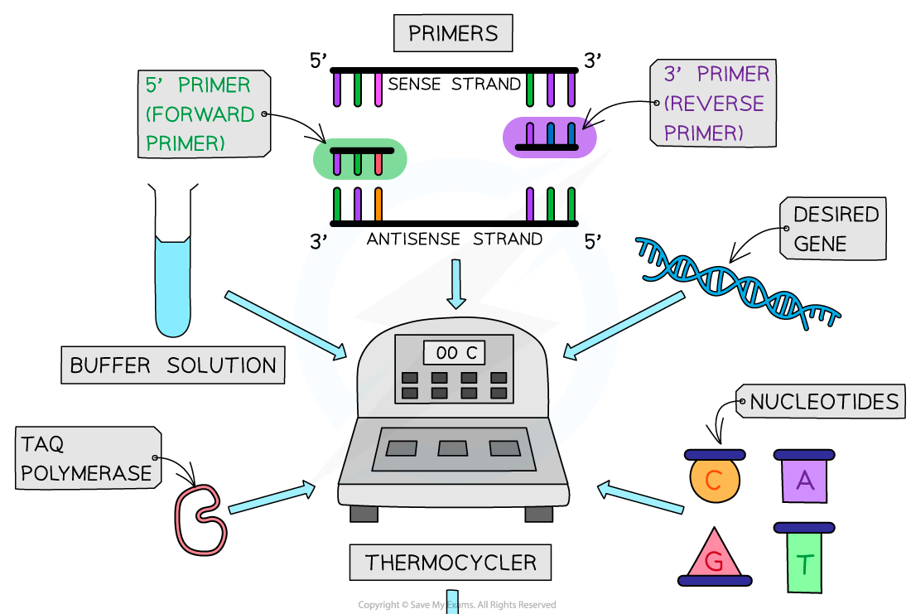

BIOINSTRUMENTATION
This is a journey about the human-instrument systems and problems encountered in attempting to obtain measurements from a living body. It also includes all diagnostic and therapeutic related equipment. This is an attempt to understand the medical devices applied in measurement of parameters related to cardiology, neurology and the methods of continuous monitoring and transmitting them.
CARDIAC EQUIPMENT: Electrocardiograph, Normal and Abnormal Waves, Heart rate monitor, Holter Monitor, Phonocardiography, Plethysmography; Cardiac Pacemaker- Internal and External Pacemaker– Batteries, AC and DC Defibrillator- Internal and External.
NEUROLOGICAL EQUIPMENT: Clinical significance of EEG, Multi-channel EEG recording system, Epilepsy, Evoked Potential–Visual, Auditory and Somatosensory, MEG (Magneto Encephalo Graph). EEG Bio Feedback Instrumentation.
SKELETAL MUSCULAR EQUIPMENT: Generation of EMG, Recording and analysis of EMG waveforms, Fatigue characteristics, Muscle stimulators, Nerve stimulators, Nerve conduction velocity measurement, EMG Bio Feedback Instrumentation.
PATIENT MONITORING AND BIOTELEMETRY: Patient monitoring systems, ICU/CCU Equipments, Infusion pumps, Bed side monitors, Central consoling controls; Radio Telemetry (single, multi), Portable and Landline Telemetry unit, Applications in ECG and EEG Transmission.
EXTRA CORPOREAL DEVICES AND SPECIAL DIAGNOSTIC TECHNIQUE: Need for heart lung machine, Functioning of bubble, Disc type and membrane type oxygenators, Finger pump, Roller pump, electronic monitoring of functional parameter; Hemo Dialyser unit, Lithotripsy, Principles of Cryogenic technique and application, Endoscopy, Laproscopy; Thermography – Recording and clinical application, Ophthalmic instruments.

BIOIMAGING
Bioimaging is the examination of biological structures and function using various qualitative and quantitative techniques. These sciences bring together engineers, physicists, biologists and chemists engaged in the development and the methodology for these types of examinations. Several aspects of bioimaging are confined to research while some have been adapted for live studies i.e. for the detection of biological conditions (diseases and abnormalities) in humans.

Light microscope
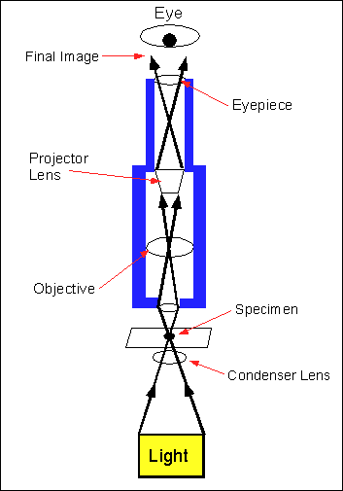 | What is fluorescence ?  - Light strikes on some molecules.  - Molecules absorb high energy e.g. blue light, & get excited.  - Some of this energy (red line) is lost internally.  - Molecules emit light/photon with less energy (green line). This is called fluorescence.  - Fluorescent dye emits green light when hit / excited with blue light.  - Fluorescent dye is attached to specific part which can be seen.  - For different colour of fluorescent dye, the excitation light is different.

How does a fluorescence microscope works?
Violet light strikes on dichroic mirror through lenses.  Dichroic mirror reflects light shorter than certain wavelength & passes light of longer wavelength than that wavelength.  Eye sees only emitted light (red) from fluorescent dye, rather than scattered purple light.  Filters help to prevent different wavelengths of light from going the wrong direction  Above type is called Epifluorescence microscope where objective is illuminated from above side. It collects all the information from the specimen hence also called as  “ wide field microscope”. | 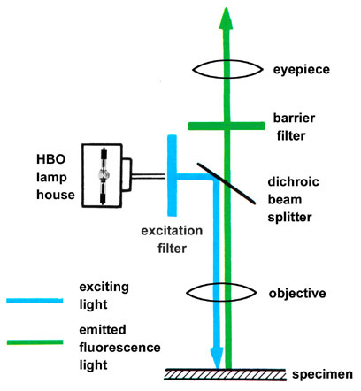

How this is related to confocal microscopy?

Condenser
Lens
Pinhole 1
Pinhole 2
Objective
Lens
Specimen
Detector

Above 2 lenses are inside.
Light is focused from focal point of one lens to another point (blue rays)
From another point (not focal point) red rays are focused. Hence image formed by this point is at different point than blue point. Thus for a lens to form image pts. don’t need to be at focal pt. of the lens.
Blue pt. is at focus of lens & we want to look at it.
If a screen with a pin hole is put at other side of lenses, at the image of blue pt. then all light from original blue pt. will pass thro’ this pinhole. Lt. from red pt. is out of focus at this screen & gets blocked by pinhole.
This is solved in following way ---
Normally specimen is completely illuminated by excitation lt. So, whole sample fluoresce at one time. Highest intensity of excitation is at focal pt. of lens, but other parts also get some of this lt. & fluoresce, resulting into haze background in resulting image. By adding pinhole/screen combination this problem is solved.
As focal pt. of objective lens forms image at pinhole, these 2 pt.s are known as “conjugate pts.” (Specimen plane & pinhole are conjugate planes.)
Pinhole is conjugate to focal pt. of lens. Hence confocal pinhole.
[In ordinary lt. microscope tissue has to be sliced into thin sections, thinner the section clear the image. But sectioning looses 3D information. Parts above & below focal plane also get illuminated & these regions give “out of focus “blur image. Hence interpretation of image becomes hard]

How does a confocal microscope works?

Laser provides high intensity excitation light  Laser light (blue) reflects off dichroic mirror.  Then this lt. hits 2 scanning mirrors mounted on motors.  Mirrors scan laser across the specimen over regular raster pattern (rectangular pattern of scanning in lateral X,Y direction ) & Z direction by fine focusing of objective.  Dye in the specimen fluoresces.  Emmited lt. (green) gets descanned by same mirrors that scan excitation lt. (blue) from laser.  In practice this is done 3 times a second. | 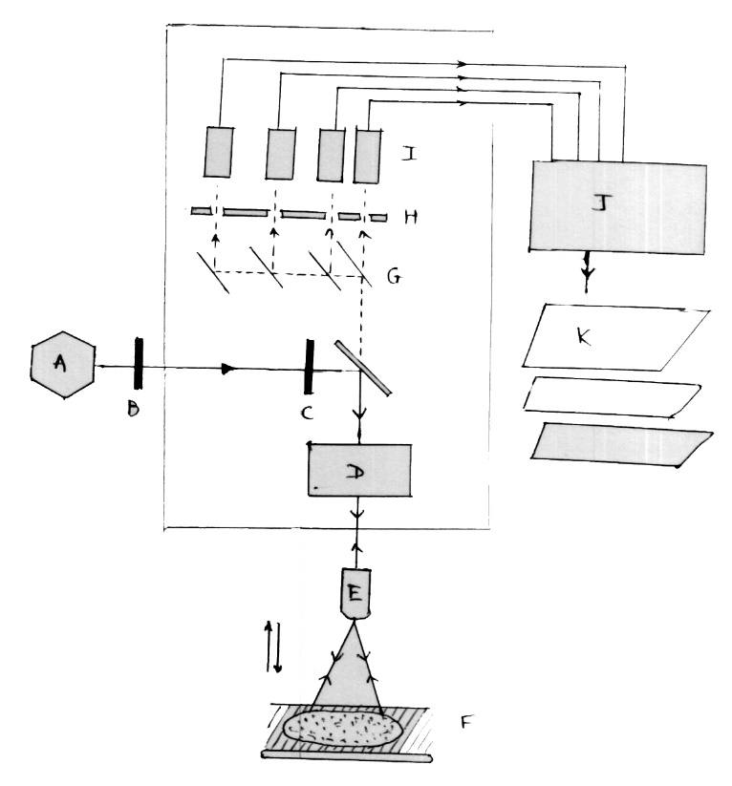

- Emitted light passes through a dichroic mirrors, focused onto pinhole.
- Light passing through a pinhole is measured by detector --- Photo Multiplier Tube.(PMT)
- At any given instant image of only one pt. of specimen is observed instead of complete image of sample.
- PMT is attached to computer that builds up 3D image , 1 pixel at a time.

Advantage of confocal microscope?

- Due to confocal pinhole, microscope is really efficient at rejecting ‘out of focus fluorescent lt.
- Practical effect of this is that image comes from a chosen plane in a thick specimen i.e. thin section (small depth of field) of specimen.
- Many thin sections thro’ specimen are scanned, a very clean 3D image of specimen is built up by computer.
- Sharper images of specimen than those produced by epifluorescence microscope.

Process:--
For imaging either fixed or living cells and tissues, they are labeled with one or more fluorescent probes. A large number of such probes are available and when they are incorporated,
1. They specifically stain certain cellular organelles and structures such as.
Nuclei, Golgi apparatus, Endoplasmic reticulum, Mitochondria, Polymerized actins inside the cells
2. Probes are also used for -Monitoring cellular integrity (live versus dead), endocytosis, exocytosis, membrane fluidity, protein trafficking, signal transduction and enzymatic activity. -Genetic mapping and chromosome analysis in the field of molecular genetics
3. The fluorescent probes are constructed around synthetic aromatic compounds. They are designed to bind with a biological macromolecule like a protein or nucleic acid. Otherwise they are designed to localize within a specific structural region such as the cytoskeleton, mitochondria, golgi apparatus, endoplasmic reticulum and nucleus.
4. Other probes are employed for – -Monitoring dynamic processes
-Monitoring localized environmental variables like concentration of inorganic metallic ions, pH, reactive oxygen species and membrane potential.

Applications of confocal microscopy:
- Wide variety of studies in neuroanatomy and neurophysiology
- Morphological studies of different types of cells and tissues
- Resonance energy transfer
- Stem cell research
- Photobleaching studies
- Lifetime imaging
- Multiphoton microscopy
- Total internal reflection
- DNA hybridization
- Membrane and iron probes
- Bioluminiscent proteins
- Cell biology, genetics, microbiology.
Fluorescence Activated Cell Sorting (FACS)

In multicellular organisms all the cells are identical in their DNA but the proteins vary tremendously. Therefore it would be very useful to separate the cells that are phenotypically different from each other and also to find out how many cells expressed the protein of interest and how much protein they expressed. FACS is a method that can accomplish all these goals.

Principle and working:
The cells are placed into a flask and are forced to enter a small nozzle one at a time. The cells travel down the nozzle which is vibrated at an optimal frequency to produce drops at fixed distance from the nozzle. As the cells flow down the stream of liquid, they are scanned by a laser. Some of the laser light is scattered by the cells and this is used to count the cells. This scattered light is also used to measure the size of the cells.
If we want to separate a subpopulation of cells, the cells of interest can be tagged with an antibody linked to a fluorescent dye. The antibody is bound to a protein that is uniquely synthesized/expressed in the cells which you want to separate. The laser light excites the dye which emits colour of light that is detected by the photomultiplier tube or a light detector. By collecting the information from the light (scatter and fluorescence) a computer can determine which cells are to be separated and collected.
The final step is sorting the cells. It is accomplished by electrical charge. The computer determines how the cells will be sorted before the drop forms at the end of the stream. As the drop forms, an electrical charge is applied to the stream and the newly formed drop will form with a charge. This charged drop is then detected left or right by charged electrodes and into waiting sample tubes. Drops that contain no cells are sent into the waste tube. The end result is three tubes with pure subpopulations of cells. The number of cells in each tube is known and the level of reference is also recorded for each cell.

Diagram for FACS machine:
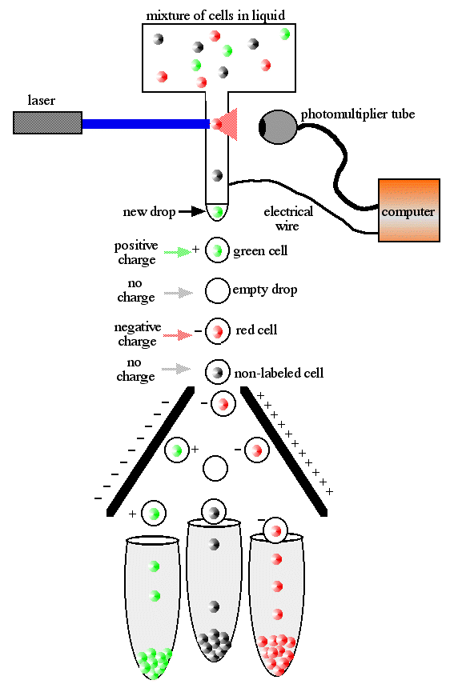

X ray method of bioimaging:

X rays are penetrating, ionizing radiation with wavelengths extending from about 200-10 pm (1 pm = 10-12 m), thus they lie below UV spectrum. X rays can be absorbed, diffracted and scattered but can not be focused or deflected by the magnetic field. They travel in straight lines from their source (usually tungsten as metal with high atomic number bombarded with high velocity electron). | 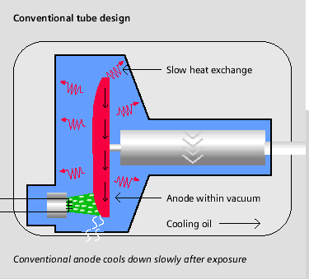

A professor of physics, Wilhelm Conard Roentgen, has discovered the X rays in 1895.
X ray film is similar to the photographic film with a photosensitive emulsion composed of fine grains of silver halide. The course grain emulsion does not produce good resolution.

Technique: The X rays are produced at the source (conventional tube design) and allowed to pass through the patient’s body maintaining specific angle to provide maximum exposure to the body part or organ of diagnostic interest. The rays get attenuated due to their interactions with different tissues. Hard tissues like bone have minimum interaction with the X rays and thus they easily pass through these while the radiations get scattered by the areas having more spaces in the organs filled with gaseous molecules. The rays emitted out from the body are captured on to the X ray film placed at the other side and the image obtained is used for getting the information.

Merits and demerits of the plain X ray:
The X ray technique emerges out as a cheapest source of information about the body tissues. The machine used for X ray comparatively easy to operate and also available in portable form. The method is non invasive i.e. it does not require any surgery or introducing any drug or instrument in the body. It is one of the rapid method of investigation which is easy to interpret. Nevertheless, the technique uses ionizing radiations, exposure to which is harmful for the patient and operator as well. Further, the outputs from X ray technique are static and two dimentional.

Examples:
Chest X ray: This is one of the best examples of X ray out put where due to the position and unique structure of the chest, large amount of invaluable information can easily be obtained. The biological contrast is developed by the bones and lungs and technically it can be enhanced by adjusting the radiations. This method extends useful diagnostic information in case of tumor, swelling, fracture, abnormal growth that significantly contribute in tuberculosis, lung or breast cancer, chest bone fractures, pneumonia etc.

Computed Tomography (CT)

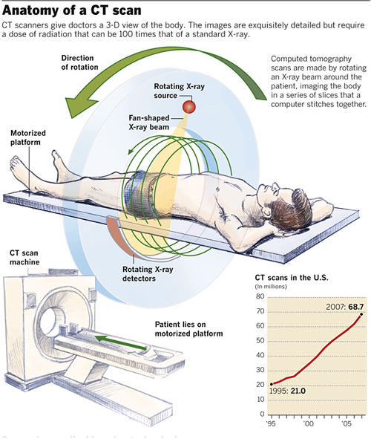

It is a medical imaging method employing tomography (tomos- slice, graphein- to write). Digital geometric processing is used to generate a 3D image of the inside of an object from a large series of 2D X-ray images taken around a single axis of rotation. It is also known as CAT – Computed Axial Tomography.

CT produces a volume of data that can be manipulated, through a process known as windowing in order to demonstrate various structures based on their ability to block the x-ray beam. Earlier scanners used to generate images in axial or transverse planes. But modern scanners allow the reformatting of the volume of data in various planes so that even 3D representations of structures are possible.

Dynamic volume CT:
- 320-slice CT scanner
- 16cm anatomical coverage
- It can scan entire organs like heart and brain in just one rotation.
- This also enables the dynamic processes such as blood function to be observed.
Advantages:
The patients with symptoms of a heart attack or stroke have until now normally had to submit to a variety of exanimations for precise diagnosis. It took a considerable time. With dynamic CT scan -
1-the time has decreased to a few minutes
2-there is one single examination
3-functional imaging can be performed rapidly
4-least possible radiation and contrast dose
5-very high precision

DRR – Digitally Reconstructed Radiograph:
It is a simulation of a conventional 2D X-ray image, created from CT data. A conventional X-ray image/radiograph is single 2D view of total x-ray absorption through the body along a given axis. Two objects, say bones, in front of one another will overlap in the image. On the other hand, a 3D CT image gives a volumetric representation.
Earlier CT data sets were better thought of as set of 2D cross-sectional images. DRRs are created by summing CT intensities along a ray from each pixel to the x-ray source.

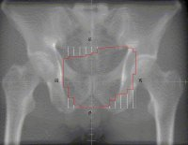

Electron beam CT (EBCT)
It has been introduced by a medical physicist Andrew Castagnini in 1980s as method of improving the resolution of CT scanners.
In a CT scanner, the X-ray source has to rotate by over 180 degrees in order to capture an image. This technique is inherently unable to capture the dynamic events or movements that are quicker than rotation time.
Principle and working:
Instead of rotating a conventional X-ray tube around the patient, the ECBT machine houses a very huge vacuum tube in which an electron beam is electro-magnetically steered towards an array of tungsten X-ray anodes arranged circularly around the patient. Each anode is hit in turn by the electron beam and emits X-rays that are collimated and detected as in conventional CT.
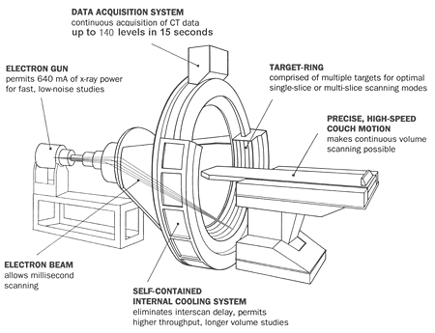

Advantages:
1-The lack of moving parts allows quick scanning
2-Single slice acquisition in 50-100 millisec
3-The technique is ideal for capturing images of the heart
4-EBCT has found particular use for assessment of coronary artery calcium, a means of predicting risk of coronary artery disease.
Drawback:
The very high cost of EBCT equipment, and its poor flexibility (EBCT scanners are essentially single-purpose cardiac scanners), has led to poor uptake, fewer than 150 of these scanners have been installed worldwide.

Diagnostic use of CT –
- Since its introduction in the 1970s, CT has become an important tool in medical imaging to supplement X-rays and medical ultrasonography.
- Although it is still quite expensive, it is the gold standard in the diagnosis of a large number of different disease entities.
- It has more recently begun to also be used for preventive medicine or screening for disease, for example CT colonography for patients with a high risk of colon cancer.
Drawback for the use of CT: Although, a number of institutions offer full-body scans for the general population, this practice remains controversial due to its lack of proven benefit, cost, radiation exposure, and the risk of finding ‘incidental’ abnormalities that may trigger additional investigations.

Magnetic Resonance Imaging (MRI):
It is a test that uses a magnetic field and pulses of radio wave energy to make pictures of organs and structures inside the body. In many cases, MRI gives different information about the structures in the body than can be seen with an X-ray, ultrasound, or CT scan. It also may show the problems that can not be seen with other imaging methods.

Uses of MRI Scan:
- It is possible to make pictures of almost all tissues in the body. The tissues that have least hydrogen (e.g. bones) look dark while those containing may hydrogen atoms (e.g. fatty tissues) look brighter.
- By changing the timing of radio waves it is possible to gain information about different types of tissues that are present.
- The scan also provides clear pictures of the parts of the body that are surrounded by bone tissues. So it is useful for examining brain and spinal cord.
- While finding benign and malignant tumors in brain it gives very detailed pictures and hence it is the best technique for the purpose. Also finds out the spread of the tumor into the nearby brain tissue. It focuses on the details in the brain, e.g. to diagnose the multiple sclerosis with the abnormal strands of tissues in the brain or to find out the changes in brain after bleeding or effects of lack of oxygen after a stroke.
- It detects the congenital heart defects as well as the changes in heart muscles after heart attack.
- Also useful for examining the joints, spine, and soft tissues like kidney, liver and spleen.

The differences between MRI scan and CT scan
MRI scan CT scan
i. It is possible to take pictures from almost i. Shows pictures only horizontally
every angle.
ii. No ionizing radiations involved ii. X-rays (ionizing radiations) used.
iii. Generally more detailed scans iii. Less detailed scans.
iv. Clearer differences between normal and iv. Such differences are less clear. abnormal tissues
v. Can take pictures of almost all tissues. v. Can’t take pictures of fatty tissues.

Types of MRI:
- MRI of Head – can look at the brain for tumors, an aneurysm, bleeding in the brain, nerve injury and other problems such as damage caused by a stroke. It can also find problems of the eyes and optic nerves, ears and auditory nerves.
- MRI of Chest – can look at the heart, the valves, and coronary blood vessels. It can show if there is any damage in heart or lungs. Such MRI also can scan for breast or lung cancer.
- MRI of blood vessels – is carried out to look at blood vessels and the flow of blood through them. This procedure makes use of a contrast material to see the blood vessels more clearly and it is termed as Magnetic Resonance Angiography (MRA). It can find problems of arteries and veins such as aneurysm, a blocked vessel, or the torn lining of a blood vessel.
- MRI of abdomen and pelvis – It can find problems in the organs and structures in the belly such as liver, gall bladder, pancreas, kidney and urinary bladder. It is used to find tumors, bleeding, infection and blockage. In women it can look at the uterus and ovaries whereas in men it looks at the prostate.
- MRI of bones and joints – can check for problems of bones and joints, such as arthritis, problems with temporo-mandibular joint, bone marrow problems, bone tumors, cartilage problems, torn ligaments or tendons, or infection. It can also tell if a bone is broken when X-ray results are not clear. More commonly done than other tests to check the problems of joints and bones.
- Spine MRI – can check the intervertebral discs and nerves of spine for conditions like spinal stenosis, disc bulges and spinal tumors.

Biosensors
Definition: It is a device that detects, records, converts, processes and transmits information regarding a physiological change or process
Biosensor employs a biological material to specifically interact with an analyte.
Analyte is a compound whose concentration is to be determined by the biosensor.

A successful biosensor possesses following features:
1. It must be highly specific for the purpose of the analyses.
2. Stable under normal storage conditions and also stable over a large number of assays.
3. The reaction should be independent of physical parameters like pH, temperature, stirring.
4. Should allow the analysis of samples with minimal pre-treatment.
5. If the reaction involves cofactors or coenzymes, they should be co-immobilized along with the enzyme.
6. The response should be accurate, precise, reproducible and linear and free from electrical noise.
7. For invasive monitoring in clinical situations, the probe used must be tiny, biocompatible, non-toxic, and non-antigenic.
8. If it is to be used in fermenters, it should be sterilizable, and should not be fouling or undergo protoeolysis.
9. It should be cheap, small, portable and capable of being used by semi-skilled operators.
10. There should be market for the biosensor and encouragement for developing them by various government subsidies etc.

Parts of a biosensor:
It consists of 3 parts
- The biological component – The biological component is immobilized on the transducer. It recognizes the analyte, reacts with it and produces a physical change. The biological component/material can be tissue, microorganisms, organelles, cell receptors, enzymes, antibodies, nucleic acids. The sensitive materials can be created by bioengineering.
- The transducer/detector – It detects the change produced by the biological element that has reacted with the analyte and transforms the signal resulting from the interaction of the analyte with biological element into electrical signal.
- The associated electronics – the amplifier, processor and the display unit.

The transducer, amplifier and the display unit together constitute the physical components of the biosensor. The signal produced by the reaction between the biological and the analyte is essentially small. It is amplified by an amplifier. Then it is fed to a microprocessor or the signal is processed, interpreted and displayed (usually on a computer).
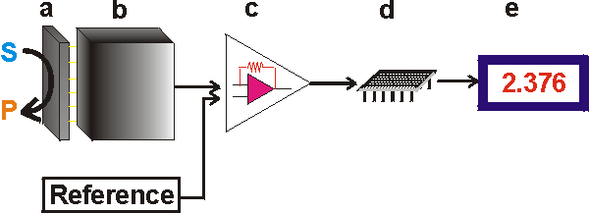

Working of a Biosensor:
a) The biological component reacts with bound analyte, after the reaction analyte diffuses from the solution to the surface of a biosensor.
b) The analyte reacts specifically and efficiently with the biological component.
c) The reaction changes the physico-chemical properties of the transducer surface.
d) This leads to the changes in the optical or electronic properties of the transducer surface.
e) This change is measure and converted to an electrical signal.
f) The signal is then amplified, processed and displayed in an user-friendly manner.
Example:
1) Blood glucose biosensor – uses the enzyme glucose oxidase to break blood glucose down in the following way.
a.It oxidizes glucose and releases electrons. b. Uses 2 electrons to reduce FAD to FADH₂.
c.FADH₂ gets oxidized by accepting 2 electrons from the electrode in a no. of steps.
d.The resulting current is a measure of the concentration of glucose.
Here, the electrode is a transducer and the enzyme glucose oxidase is the biologically active component.
2) Other examples –
- electric nose by applying different detector molecules,
- a canary in a cage to warn a gas is used by miners and also
- use of the organisms which respond to toxic substances at a much lower level than us to warn us about their presence.
Such devices are used in environmental monitoring and water treatment facilities.
Types of biosensors:
A) Thermometric: Based on measurement of heat.
Calorimetric/ thermometric: The biological component used is Enzyme. The enzyme catalyzed reactions produce heat. The biosensor measures the change in the temperature of the solution containing the analyte after the enzyme action and interprets in terms of analyte concentration in the solution. This biosensor can detect the temperature difference of 0.0001⁰C. e.g. estimation of serum cholesterol etc.

B) Electrochemical: Based on measurement of electric current, ionic or conductance changes. It is carried out by bioelctrodes.
Potentiometric: The biological component used is Enzyme. Many enzyme catalyzed reactions generate or use H+ ions. This biosensor uses ion-selective electrodes to convert the biological reaction to electronic signal. It detects and measures the evolution of a gas. e.g. detection of urea by using the enzyme urease
Amperometric: The biological component used is Enzyme. The biosensor contains oxygen electrodes that function by production of a current when potential is applied between the two electrodes. The enzymatic reactions carry out redox reactions (changes in electron distribution). It detects the movement of electrons due to these redox reactions. The magnitude of the current is directly proportional to the substrate concentration. e.g. glucose detecting biosensor based on glucose oxidase.
Conductimetric: The biological component used is Enzyme. This biosensor detects the electrical conductivity produced by the changes in the concentration of ionic species. e.g. urea detection by urease. This reaction gives rise to a large in ionic concentration detected by the biosensor. It is used to monitor urea concentration during dialysis and renal surgery.

C) Optical: The biological component used is Enzyme, antibody, DNA/RNA. Enzymes carry out catalytic reactions and the other types of molecules carry out affinity reactions. The biosensors measure a change in fluorescence or in absorbance caused by the products generated from such reactions. e.g. using luciferase enzyme for detecting microorganisms in urinary track infections, changes in the bacterial cells and other unicellular organism, critical care and surgical monitoring with respect to detection of pH, PCO_{2,} PO₂

D) Acoustic waves/ Piezoelectric: Certain crystals contain +ve and –ve charges which separate after subjecting to stress. These crystals vibrate with characteristic frequency which generates electric effect and this effect is called piezoelectric effect. The biological component used here is antibody which is bound to the surface of crystals. When the analyte binds to the biological component, the biosensor detects the altered resonant frequency of the crystals due to the changes in its mass. e.g. detection of explosives, narcotic drugs and insecticides and pesticides. The use of this biosensor is restricted to detection of gaseous or solid material as crystals stop ocillating in liquid.
There are many potential applications of biosensors of various types. For a biosensor approach to be valuable in terms of research and commercial applications, the main requirements are – a. identification of a target molecule b. availability of a suitable biological recognition element and c. the potential for disposable portable detection system (preferred to sensitive laboratory-based techniques in some cases)
Applications of biosensors:
a) In medicine & Health:
Quantitative estimation of glucose monitoring in diabetic patients, monitoring of cholesterol, urea, CO₂, O_{2,} toxic compounds in body fluids; blood gas monitoring is important in critical care and surgery

b) Industrial application: For monitoring fermentation products in food and pharmaceutical industries, routine analytical measurement of folic acid, biotin, vitamin B 12 as an alternative to microbiological assay. Detection of toxic metabolites such as mycotoxins in foods, measuring odder, freshness of stored food by enzyme ATPase as ATPase is absent in spoiled food especially fish. Determining cholesterol concentration in food (milk and milk products). Protein engineering in biosensors

c) Environmental applications:
The detection and determining concentration of pesticides and river water contaminants i.e. organophosphates in insecticides and pesticides. BOD and pollution mutagenecity. Determination of levels of toxic substances before and after bioremediation. Remote sensing of airborne bacteria e.g. in counter-bioterrorist activities

d) Security applications:
Military activities: The detection of explosives with high selectivity and sensitivity within limitaed time
Rehabilitation center & police, forensic investigations: Mobile equipment for drug and narcotic detection with high specificity for investigating
Unwanted drugs are detected by checking containers, trucks, cars by an easy swipe on the handle, doors, steering wheels, wrapping etc. and results are obtained immediately. Thus also for screening procedures at airports and naval ports.
Nanotechnology
Nanotechnology sometimes shortened to “Nanotech” refers to a field whose theme is the control of matter on an atomic and molecular scale. Generally Nanotechnology deals with structures 100 nanometers or smaller and involves developing materials or devices within that size.
Two main approaches are used in Nanotechnology.
- “Bottom-up” approach - materials and devices are built from molecular components which assemble themselves chemically by principles of molecular recognition.
- “Top-down” approach - nano objects are constructed from larger entities without atomic-level control.

Biology & Nanotechnology
- Recently there has been the development of nano-biosensors
- In situ intracellular measurements of single cells using antibody-based nanoprobes. The nano-scale size of this new class of sensors also allows for measurements in the smallest of environments.
- Using these nanosensors, it is possible to probe individual chemical species and molecular signalling processes in specific locations within a cell.
- Insertion of a nano-biosensor into a mammalian somatic cell not only appears to have no effect on the cell membrane, but also does not affect the cell’s normal function.
- The possibilities to monitor in vivo processes within living cells could dramatically improve our understanding of cellular function, thereby revolutionizing cell biology.
- Biological and Medical applications would require nanoparticles to be conjugated to biomolecules. A universal approach for conjugation of silver colloidal nanoparticles to biomolecules has been developed. Surface functionalized silver colloids were labeled with a Raman active dye and bioreceptor molecule and used as labels for cellular imaging.

AI in healthcare
1. Surgery a. Micro dissections and access tiny areas b. Robert arm- brain and heart, absolute accuracy c. Lessen complications and minimise blood loss d. All procedures can be stored in digital media hence helps in Surgeon education and training.
2. Medical Imaging a. Support labour intensive image scanning and case triage by surfacing valid insights to help Radiologists identify critical cases first b. Accurate diagnosis c. Health care sector for patterns and algorithms
3. Disease diagnosis and treatment
4. Accelerated drug development a. Example, in 2007 a robot called Adam could combine billions of data points and investigate the diverse roles of yeast. It identified 19 genes that made up yeast and forecasted 9 new precise ideas. b. Another robot EVE, discovered that triclosan, a substance present in toothpaste is efficient against parasites related to malaria c. Accelerates medication making process and makes it cost efficient
5. Expanding access to healthcare a. Lack of radiologists and ultrasound technologists can restrict access to proper healthcare in underdeveloped countries b. Take over some diagnostic tasks. c. AI imaging may achieve an accuracy equivalent to people when screening for chest xrays for indication of tuberculosis
6. Clinical decision making a. Faster response b. Can speed up diagnosis and reduce errors
7. Data collection and administrative tasks a. Doctors spend a lot of time doing paperwork and documentation b. For administrative tasks, i. Prioritisation and schedule optimization ii. Prior authorization iii. Clinical recording iv. Revenue management v. Medical record management vi. Billing and claim process vii. Identify health plan viii. Medical benefits and services ix. Assist with gathering of paperwork
8. Getting real time data a. Make critical therapeutic decisions more quickly and effectively by using real time precise data. i. Reduce patient wait times ii. Improve preventive actions iii. Reduce costs b. Support stronger physician patient relationships c. Patients will be more involved in their treatments if this is made available through multiple devices d. Wearables i. Monitor heartbeat ii. Step trackers
9. Providing virtual nursing assistants a. Keeping track of patient health metrics, prescription usage and lifestyle choices b. Tracks a patient’s weight, blood pressure and other parameters. c. Example- MOLLY
10. Research a. Gather data from numerous sources b. More precise analysis of fatal disease

Elaborate on the process of biological computing and add a note on different spatial organizations of information processing.

Biological Computing: An Overview
Biological computing, also known as biocomputing or biomolecular computing, is a field that uses biological systems, molecules, and principles for computation. It draws inspiration from biological processes like DNA replication, neural networks, and cellular signaling to perform data storage, processing, and complex decision-making.

Key Processes in Biological Computing
- Input Representation:
  - Biological computing starts with encoding information into biological molecules, such as DNA, RNA, or proteins.
  - For example, DNA bases (A, T, C, G) can represent binary code (0s and 1s).
- Processing of Information:
  - The system processes the input using biochemical reactions like DNA hybridization, enzymatic activity, or protein folding.
  - Examples of processes:
    - DNA strand displacement for logical operations.
    - Protein-protein interactions for signal transduction.
    - Cellular decision-making pathways (like quorum sensing in bacteria).
- Output Generation:
  - The result of the computation is often detected through measurable changes in biological molecules.
  - For instance:
    - Fluorescent signals indicate specific reactions.
    - Chemical outputs like metabolites show the result of a calculation.
- Feedback Mechanism:
  - Biological computing systems can adapt or self-regulate by integrating feedback loops, similar to how cells respond to their environment.
  - This is useful for dynamic tasks like disease detection or environmental sensing.

Applications of Biological Computing
- Medical Diagnostics and Therapeutics:
  - DNA-based circuits can detect diseases and release therapeutic agents inside the body.
- Synthetic Biology:
  - Engineering cells to perform specific functions, such as producing biofuels or biosensors for toxins.
- Data Storage:
  - DNA is used for ultra-dense data storage because of its high information capacity.
- Bioengineering and Nanotechnology:
  - Biological systems are integrated into nanomachines for advanced computations.

Spatial Organization of Information Processing
Biological computing systems process information in a variety of spatially organized ways, reflecting how information flows in biological systems. These spatial organizations enable simultaneous computation across different areas, enhancing efficiency and complexity. Some notable forms include:
1. Molecular-Level Organization:
- DNA Computing:
  - DNA serves as the primary medium for computation.
  - Processes like DNA hybridization and strand displacement occur in a liquid solution, where spatial constraints are minimal.
- Protein Networks:
  - Proteins interact in confined spaces (e.g., within organelles or molecular complexes) to process signals.
2. Cellular-Level Organization:
- Intracellular Computing:
  - Cells use organelles like the nucleus and mitochondria for specialized tasks, segregating functions for efficiency.
  - Example: The nucleus processes genetic information, while the cytoplasm handles protein synthesis.
- Cell-to-Cell Communication:
  - Cells process information collectively by exchanging signals through diffusion (e.g., quorum sensing in bacteria).

3. Tissue-Level Organization:
- At this level, groups of cells act as units of computation.
- Example: Neural tissues process and transmit information using electrical and chemical signals.
- Spatial organization ensures that specific regions of the tissue specialize in certain tasks, like memory storage or motor control.
4. Organism-Level Organization:
- In multicellular organisms, information processing spans tissues and organs.
- Example: The nervous system integrates sensory inputs from across the body to make decisions and coordinate actions.
5. Distributed Biological Systems:
- Biological processes can occur in distributed systems, such as colonies of bacteria or networks of neurons.
- Each "node" in the system processes local information and contributes to the global computation.

Comparison with Conventional Computing
Aspect | Biological Computing | Conventional Computing
Medium | DNA, RNA, proteins, cells | Silicon, transistors, circuits
Speed | Slower but parallel | Faster but sequential (mostly)
Energy Efficiency | Highly efficient | High energy consumption
Fault Tolerance | Can self-repair | Limited error recovery
Scalability | Extremely scalable (molecular level) | Limited by hardware constraints

Conclusion
Biological computing represents a revolutionary approach to computation, mimicking nature’s ability to process complex information in highly efficient and decentralized ways. By harnessing the spatial organization inherent in biological systems, this field opens the door to new possibilities, from medical diagnostics to futuristic AI systems. Understanding and leveraging the spatial aspect of biological information processing can enable even more sophisticated and powerful computing paradigms.

